# INTRODUCTION

* 1. Overview

The business requirements for analyzing the performance and efficiency of Electric cars include identifying KPIs, comparing performance across different parameters and brands also, identifying patterns and trends over time, identifying affecting factors, creating interactive dashboards and reports, identifying areas for improvement, making data-driven decisions, comparing to industry average and creating forecasting models for future performance. The ultimate goal is to gain insights and improve performance through data visualization techniques.

* 1. Purpose

The objective of this project is to analyze the performance and efficiency of electric cars using Tableau data visualization application. We will analyze data from various sources including car manufacturers, charging stations, and other industry reports.

1. **Problem Definition & Design Thinking**
   1. Empathy Map

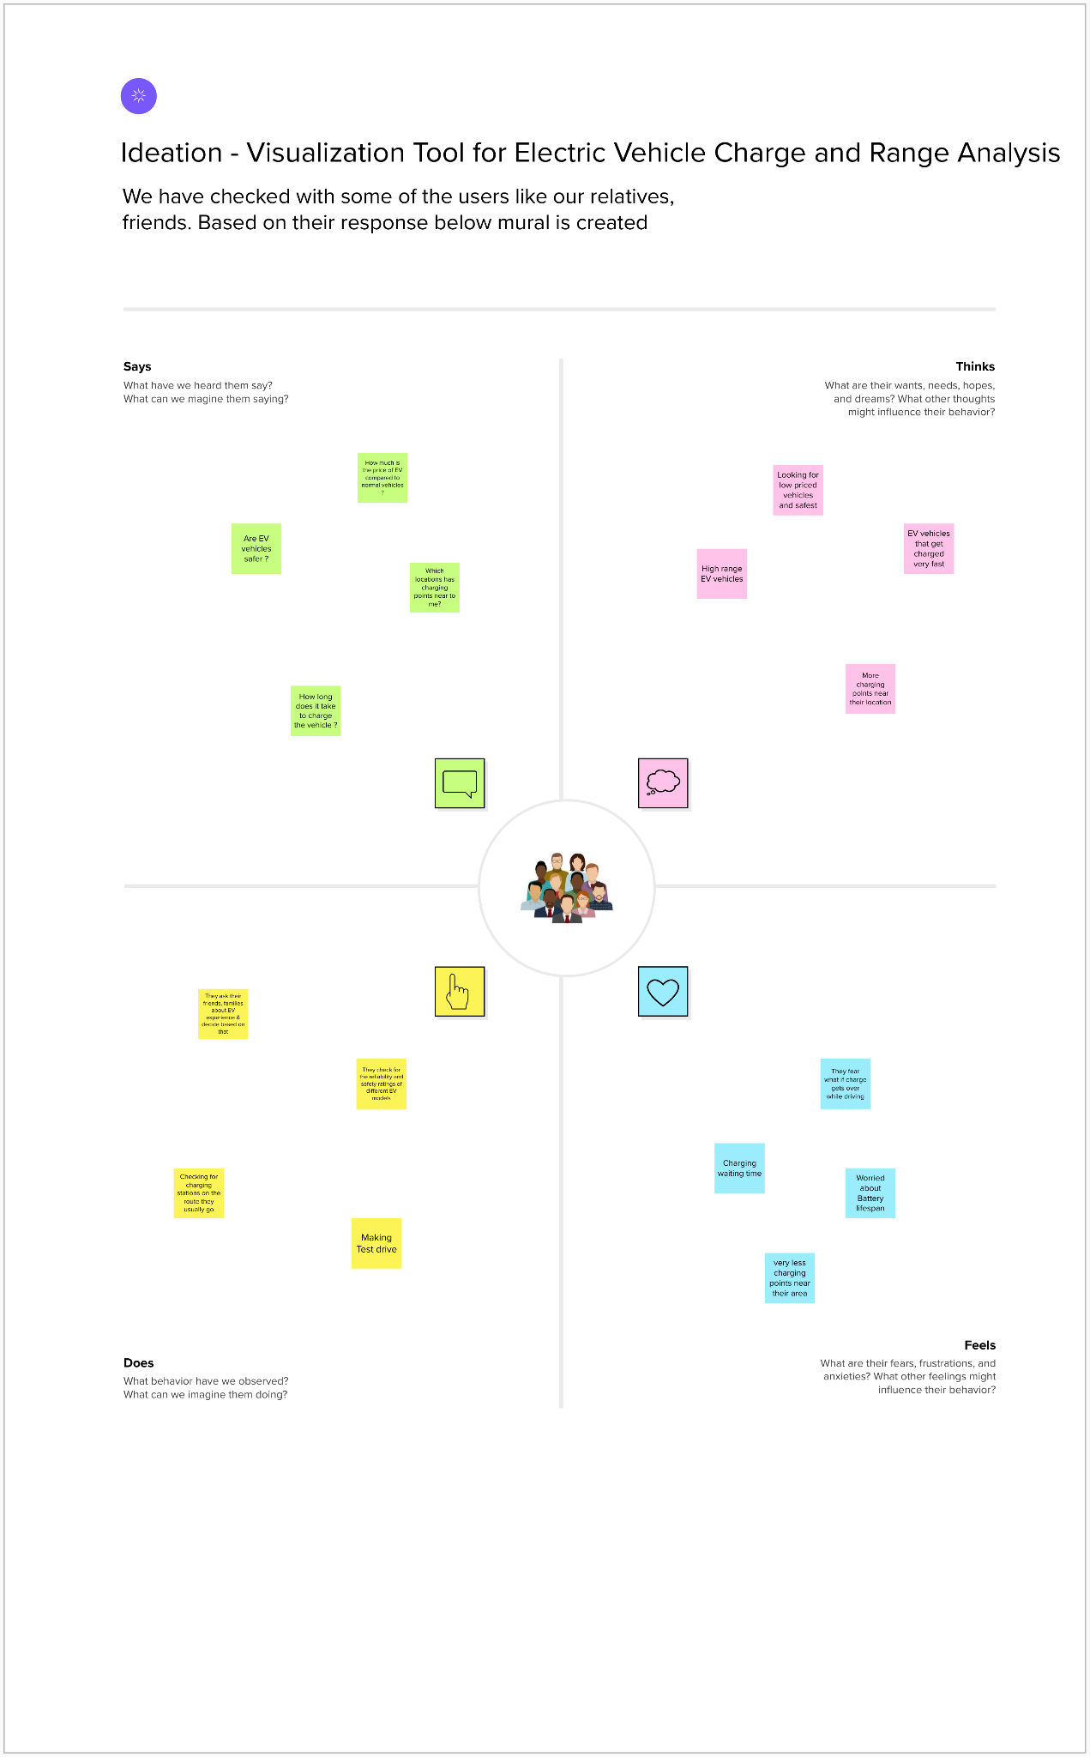

* 1. Ideation & Brainstorming Map

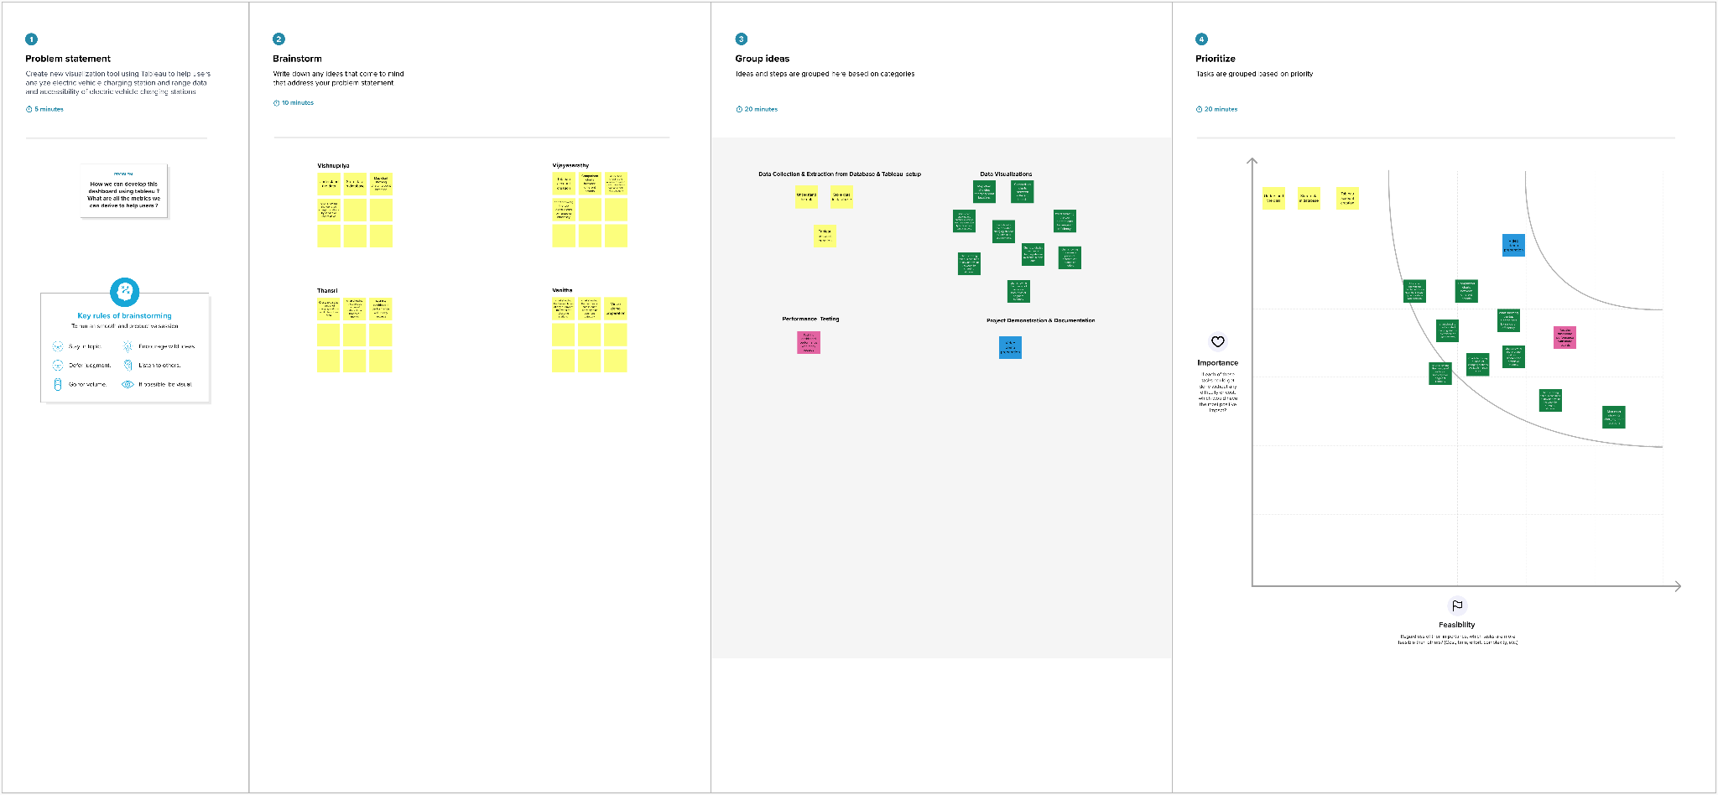

# RESULT

**Dashboard Screenshot:**

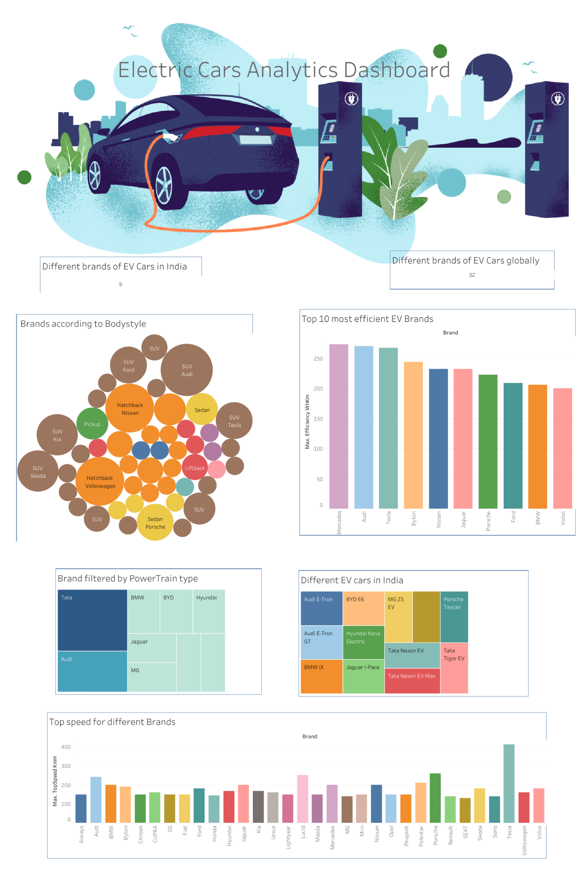

**Story Screenshot:**

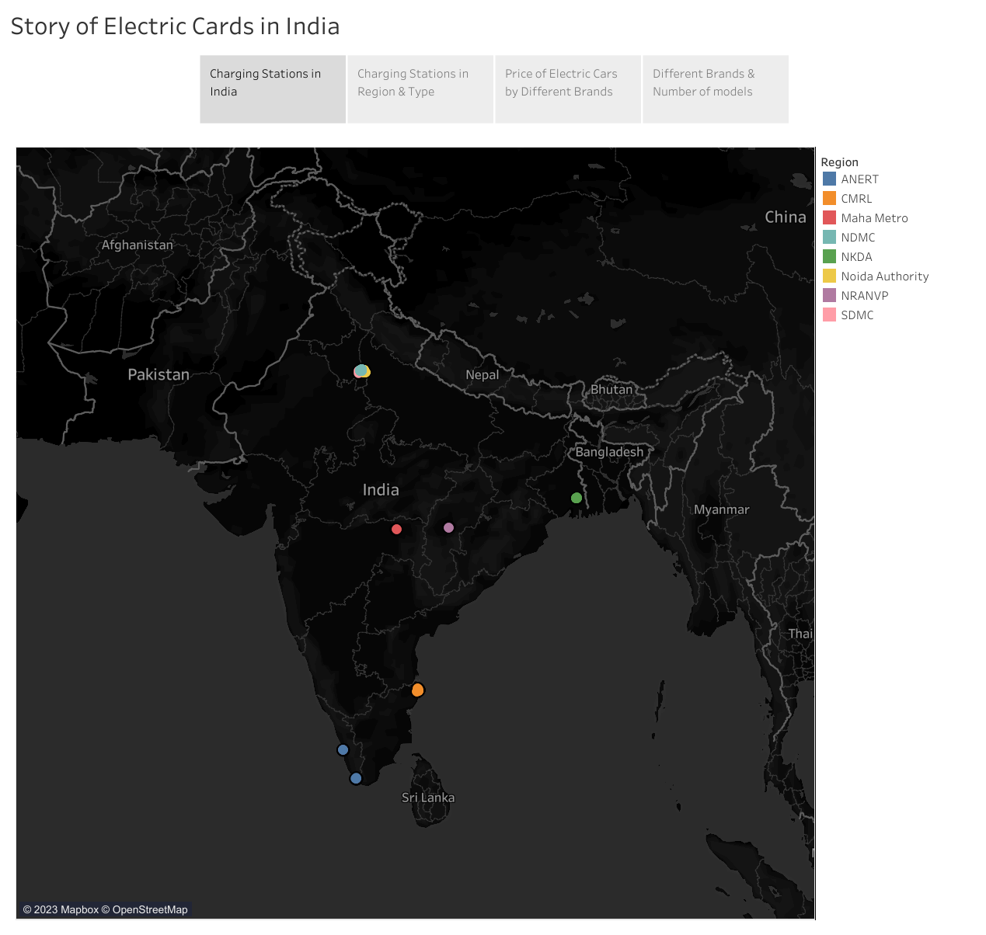

# ADVANTAGES & DISADVANTAGES

Advantages:

* Easy to get details of Electric cars details in one place
* Users can view the dashboard and make decision before buying car

Disadvantages

* Limited data

# APPLICATIONS

* Automotive Industry
* Energy Industry

# CONCLUSION

In conclusion, analyzing the performance and efficiency of electric cars using data visualization techniques is a valuable tool for gaining insights into the factors affecting their performance and making data-driven decisions to improve their efficiency.

# FUTURE SCOPE

* comparison with non-electric cars
* Integrating with real time data

# APPENDIX

NA